You will describe the data you aim to store. What is your application or business? What data will be storing? What is the value of this data? Where will the data come from? Who will use this data?

We are creating a system that where we can sell the cars multilevel organizational model and so we have created a database solution that completely keeps track of cars customers orders payments and and all their employees taken able to alter the data that what they can able to do and we need to maintain the complete records of that customer and they can able to logged into our system and they can order the water the cars that they can able to come purchase and we can even also give some discounts for the customers that who are loyal to us and here we are using a my SQL database and manually they can enter the complete information of the employee information supplier supplier information on cars and orders so we can use this from any kind of applications that they we can use through the any middleware raford transport engine

**Relational Database Design Process**

Identify at least 5 entity sets and their attributes (at least 3 attributes per entity), and describe these entities in your **report**. This will look a lot like the description component of the Aquarium assignment. Then illustrate that you understand normalization and how to use it to reduce uncontrolled redundancy in your database design by creating a single ERD diagram using either UML or Crow’s Foot notation and upload that drawing to **GitHub**. The ERD must be a **physical** model (includes data types and key information).

So here we have identified that seven entities in total a first one is car second one is org org employees order items orders status and customers and our our data model will start from org so every or will have its own or employees so that or will be on the primary key difference for our employee org ID and the same way that or will be distributed will be distributed the complete relation database process for this application

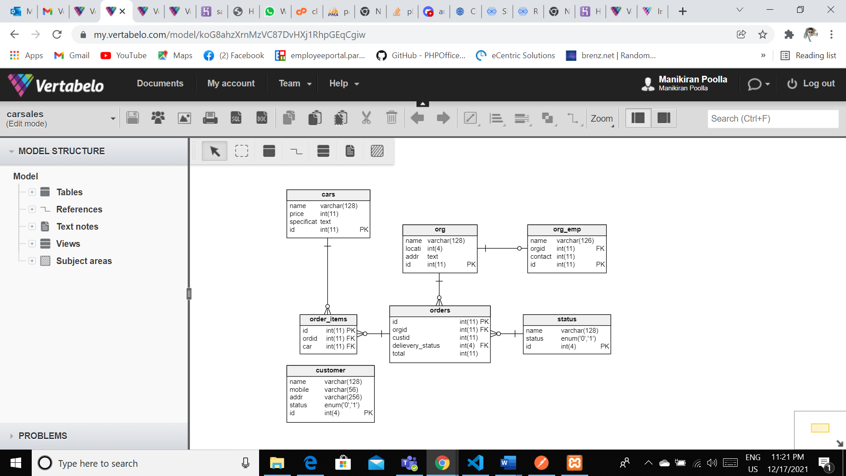

**Data Sources**

Create examples (**three** records per entity) of all of your data in a parseable format such as XML, JSON, or delimited like comma separated values and submit the files to **GitHub**. In your **report**, explain the process of how your software stores each entity and attribute, what is the source of the attributes, and what data is default.  You don’t have to describe every attribute, but I want to know at least two details about each entity, and how that data enters the system.

As a business owner insert the complete data set manually by the application where we can insert under for example if you want to insert that data off an employee so that we have to insert manually by creating a proper data model and data interface intervenes. We need to have the proper data model that where the complete data need to sit in each and every table that they have defined for each and every entity of the data model. Sometimes the data model could be need to access Jason and other datasets.

**Data Definition Language Scripts**



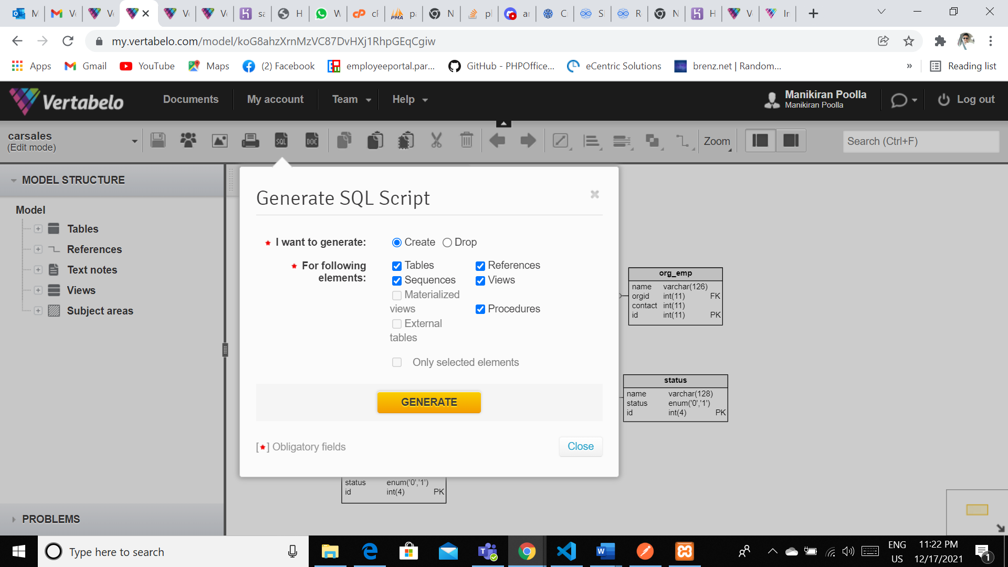

* The SQL commands for populating the tables **and** what they do (explain each of the commands and options that you used in the script) documented in your report: 8 points
* -- Created by Vertabelo (http://vertabelo.com)
* -- Last modification date: 2021-12-17 17:42:30.383
* -- tables
* -- Table: cars
* CREATE TABLE cars (
* name varchar(128) NOT NULL,
* price int(11) NOT NULL,
* specifications text NOT NULL,
* id int(11) NOT NULL AUTO_INCREMENT,
* CONSTRAINT cars_pk PRIMARY KEY (id)
* ) ENGINE InnoDB CHARACTER SET utf8mb4;
* -- Table: customer
* CREATE TABLE customer (
* name varchar(128) NOT NULL,
* mobile varchar(56) NOT NULL,
* addr varchar(256) NOT NULL,
* status enum('0','1') NOT NULL DEFAULT '0',
* id int(4) NOT NULL AUTO_INCREMENT,
* CONSTRAINT customer_pk PRIMARY KEY (id)
* ) ENGINE InnoDB CHARACTER SET utf8mb4;
* -- Table: order_items
* CREATE TABLE order_items (
* id int(11) NOT NULL,
* ordid int(11) NOT NULL,
* car int(11) NOT NULL,
* CONSTRAINT order_items_pk PRIMARY KEY (id)
* ) ENGINE InnoDB CHARACTER SET utf8mb4;
* CREATE INDEX ordid ON order_items (ordid);
* CREATE INDEX car ON order_items (car);
* -- Table: orders
* CREATE TABLE orders (
* id int(11) NOT NULL,
* orgid int(11) NOT NULL,
* custid int(11) NOT NULL,
* delievery_status int(4) NOT NULL,
* total int(11) NOT NULL,
* CONSTRAINT orders_pk PRIMARY KEY (id)
* ) ENGINE InnoDB CHARACTER SET utf8mb4;
* CREATE INDEX orgid ON orders (orgid);
* CREATE INDEX custid ON orders (custid);
* CREATE INDEX delievery_status ON orders (delievery_status);
* -- Table: org
* CREATE TABLE org (
* name varchar(128) NOT NULL,
* location int(4) NOT NULL,
* addr text NOT NULL,
* id int(11) NOT NULL AUTO_INCREMENT,
* CONSTRAINT org_pk PRIMARY KEY (id)
* ) ENGINE InnoDB CHARACTER SET utf8mb4;
* CREATE INDEX id ON org (id);
* -- Table: org_emp
* CREATE TABLE org_emp (
* name varchar(126) NOT NULL,
* orgid int(11) NOT NULL,
* contactnum int(11) NOT NULL,
* id int(11) NOT NULL AUTO_INCREMENT,
* UNIQUE INDEX orgid (orgid),
* CONSTRAINT org_emp_pk PRIMARY KEY (id)
* ) ENGINE InnoDB CHARACTER SET utf8mb4;
* -- Table: status
* CREATE TABLE status (
* name varchar(128) NOT NULL,
* status enum('0','1') NOT NULL,
* id int(4) NOT NULL AUTO_INCREMENT,
* CONSTRAINT status_pk PRIMARY KEY (id)
* ) ENGINE InnoDB CHARACTER SET utf8mb4;
* -- foreign keys
* -- Reference: order_items_ibfk_1 (table: order_items)
* ALTER TABLE order_items ADD CONSTRAINT order_items_ibfk_1 FOREIGN KEY order_items_ibfk_1 (ordid)
* REFERENCES orders (id)
* ON DELETE CASCADE
* ON UPDATE CASCADE;
* -- Reference: order_items_ibfk_2 (table: order_items)
* ALTER TABLE order_items ADD CONSTRAINT order_items_ibfk_2 FOREIGN KEY order_items_ibfk_2 (car)
* REFERENCES cars (id)
* ON DELETE CASCADE
* ON UPDATE CASCADE;
* -- Reference: orders_ibfk_1 (table: orders)
* ALTER TABLE orders ADD CONSTRAINT orders_ibfk_1 FOREIGN KEY orders_ibfk_1 (orgid)
* REFERENCES org (id)
* ON DELETE CASCADE
* ON UPDATE CASCADE;
* -- Reference: orders_ibfk_4 (table: orders)
* ALTER TABLE orders ADD CONSTRAINT orders_ibfk_4 FOREIGN KEY orders_ibfk_4 (delievery_status)
* REFERENCES status (id)
* ON DELETE CASCADE
* ON UPDATE CASCADE;
* -- Reference: org_emp_ibfk_1 (table: org_emp)
* ALTER TABLE org_emp ADD CONSTRAINT org_emp_ibfk_1 FOREIGN KEY org_emp_ibfk_1 (orgid)
* REFERENCES org (id)
* ON DELETE CASCADE
* ON UPDATE CASCADE;
* -- End of file.
* Screenshots of your successful attempts to populate each table with at least three records: 4 points

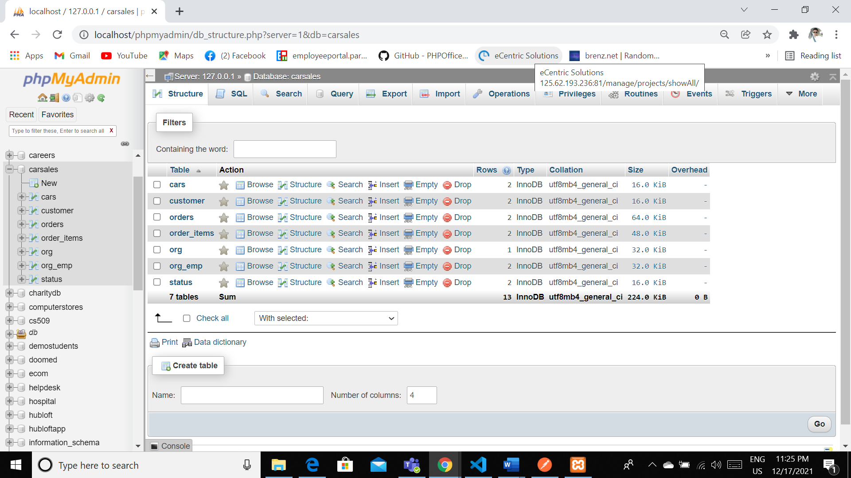

**Data Manipulation Language Scripts**

* 1 point each for the two insert statements

INSERT INTO `cars` (`id`, `name`, `price`, `specifications`) VALUES (NULL, 'Farari', '2000000', 'Sports'), (NULL, 'Porche', '14000000', 'Luxary');

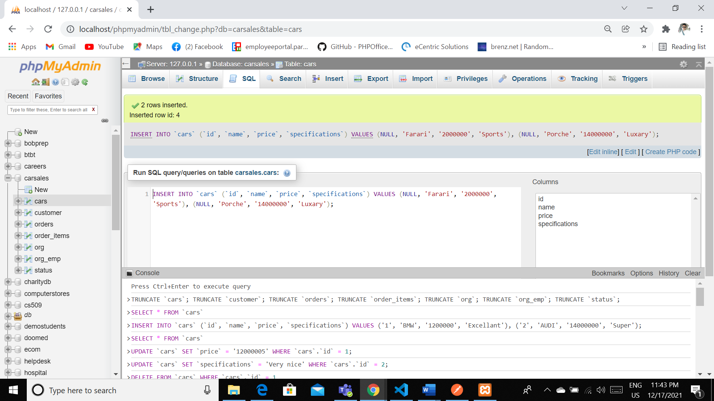

* 1 point each for the two update statements

UPDATE `cars` SET `specifications` = 'Business' WHERE `cars`.`id` = 2;

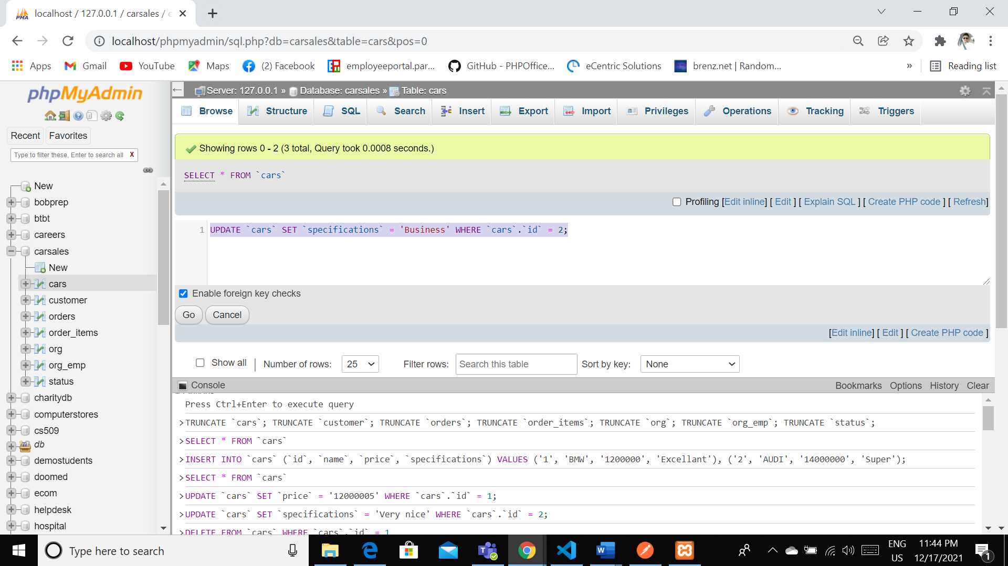

UPDATE `cars` SET `specifications` = 'Very nice' WHERE `cars`.`id` = 2;



* 1 point for the delete statement

DELETE FROM `cars` WHERE `cars`.`id` = 1

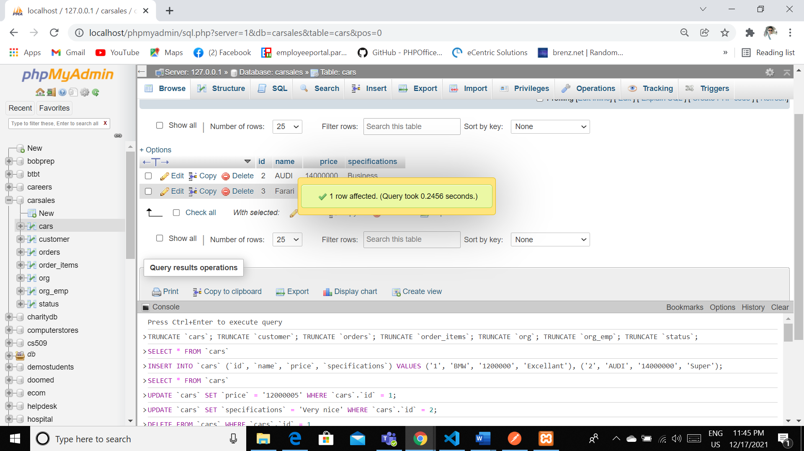

* 1 point for the simple select statement

[SELECT](http://localhost/phpmyadmin/url.php?url=https://dev.mysql.com/doc/refman/5.5/en/select.html) * FROM `cars`

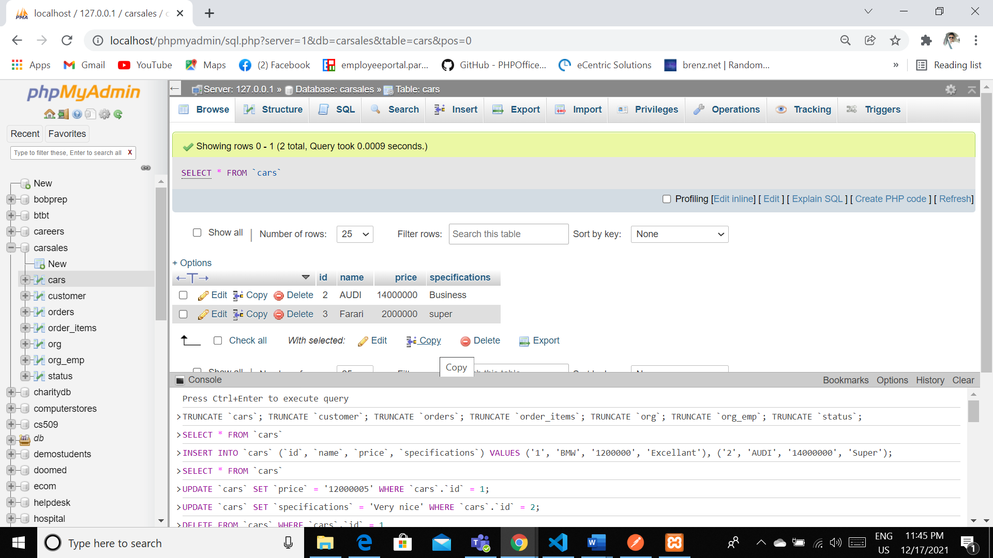

* 2 points each for the 2 join statements

SELECT O.*,oi.car FROM `orders` O LEFT JOIN order_items oi on oi.ordid=O.id

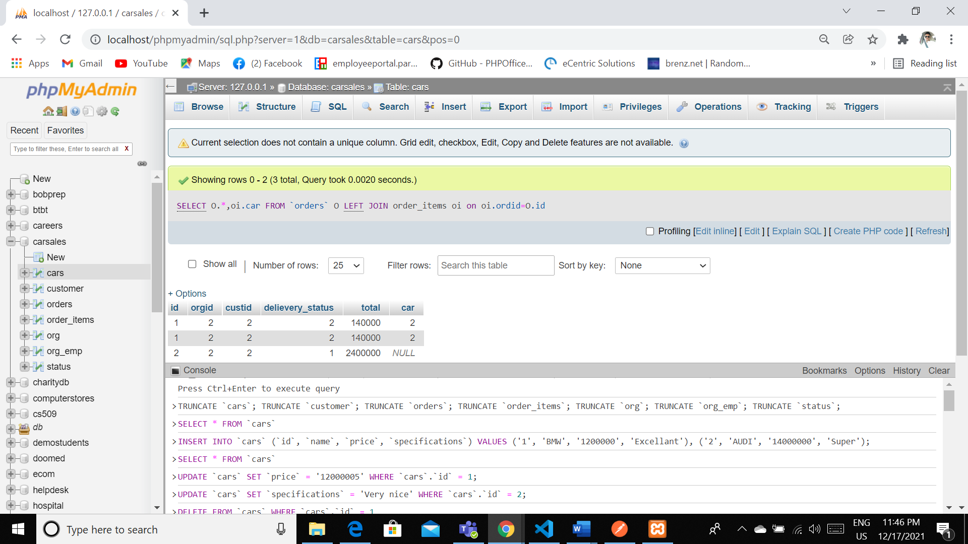

SELECT O.*,oi.car,c.name FROM `orders` O LEFT JOIN order_items oi on oi.ordid=O.id INNER JOIN cars c on oi.car=c.id

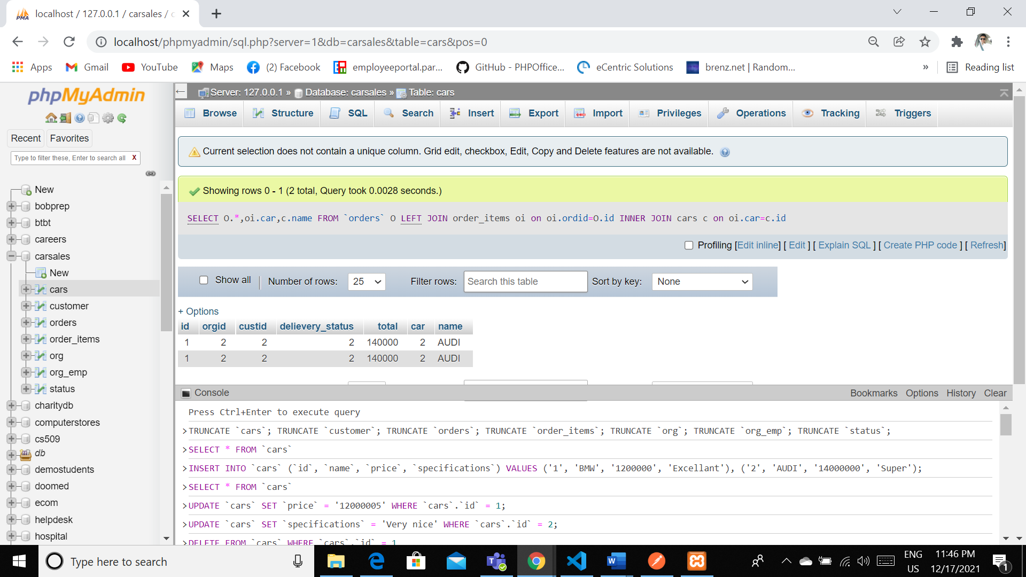

* 2 points each for the two that use summary statements

DESC `orders`

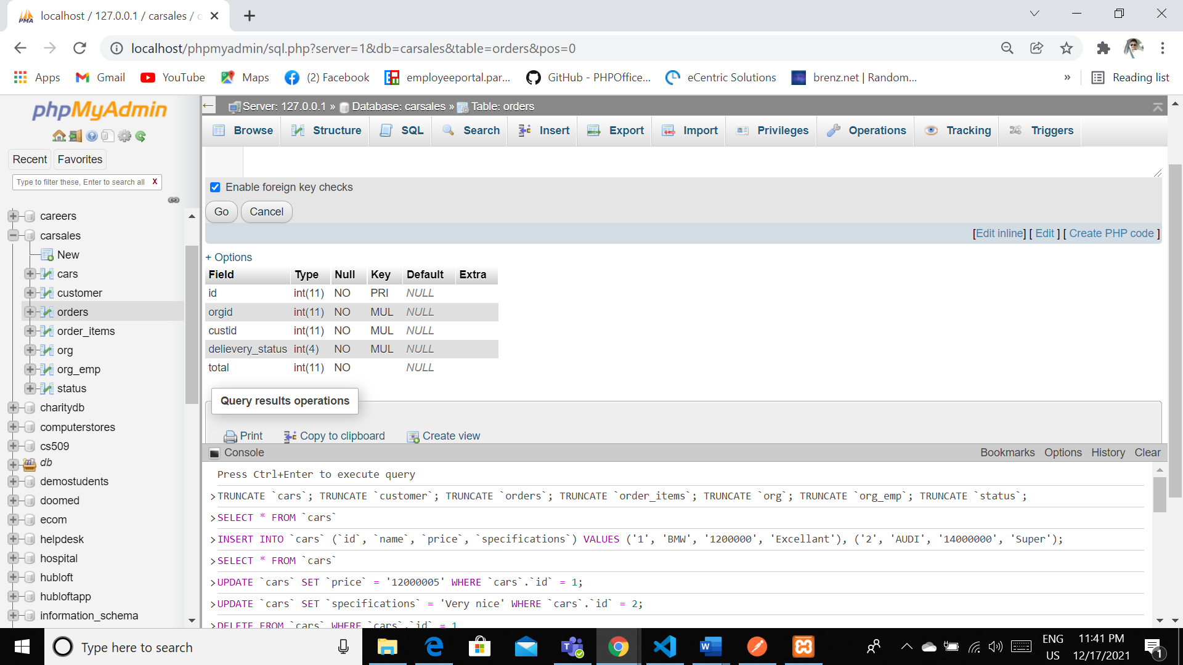

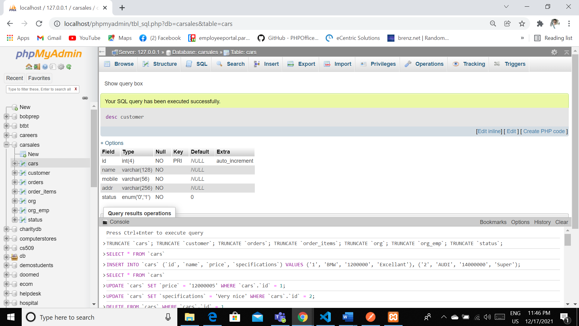

* 2 points for the multi-table query

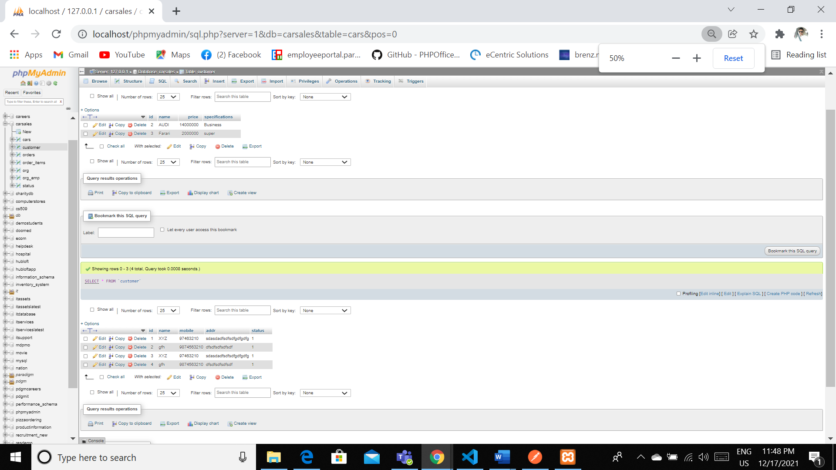

* 2 points for the query of your choice.

SELECT O.*,oi.car,c.name,cu.name customer FROM `orders` O LEFT JOIN order_items oi on oi.ordid=O.id INNER JOIN cars c on oi.car=c.id INNER JOIN customer cu on cu.id=o.custid

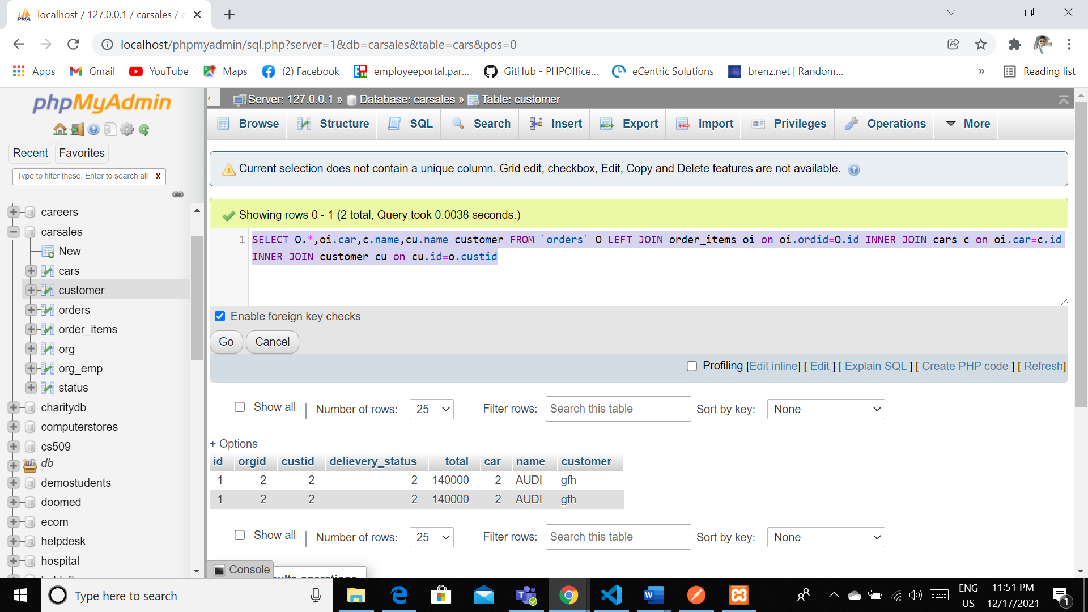

**Indexes**

* points for clearly defining at least three indexes and explaining why you chose them.

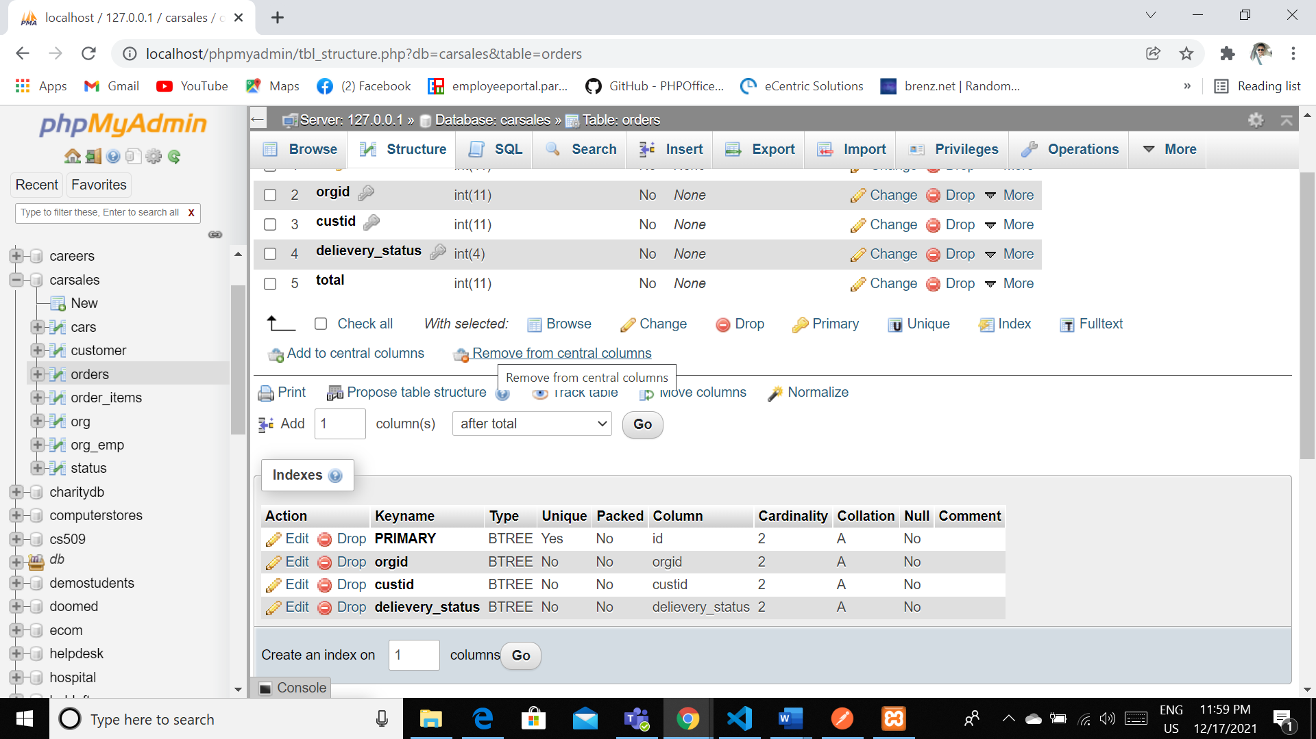

|  |
| --- |
|  |
|  |  | Yes | No | id | 2 | A | No |  |
|  |  | **orgid** | BTREE | No | No | orgid | 2 | A | No |  |
|  |  | **custid** | BTREE | No | No | custid | 2 | A | No |  |
|  |  | **delievery_status** | BTREE | No | No | delievery_status | 2 | A | No |  |

SHOW INDEX FROM orders

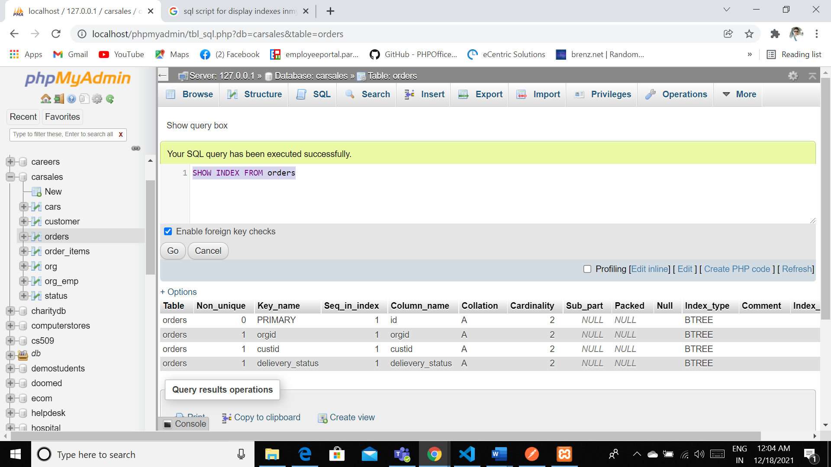

explaining how you would demonstrate the performance improvement afforded by the indexes.

In this order table we are using the three indexes as we are using this keys for the references for the table from orgid , custid and status tables. If we using this Indexes we can reduce the redundancies and they can be easily managed so that they can be organized properly

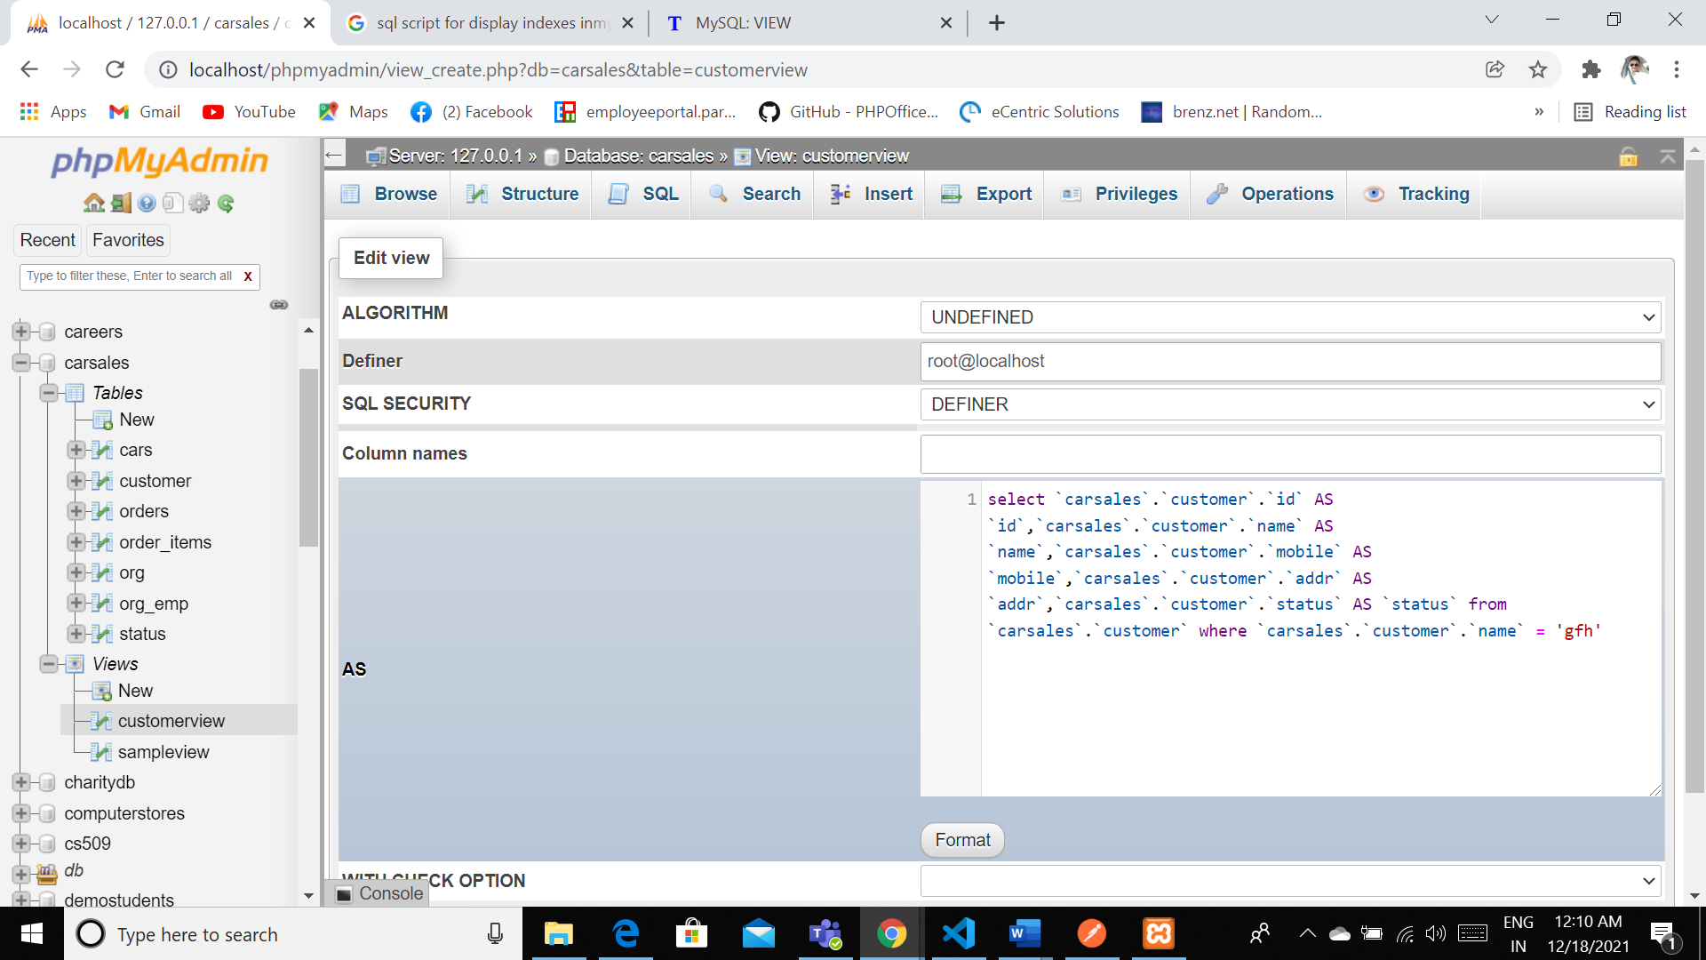

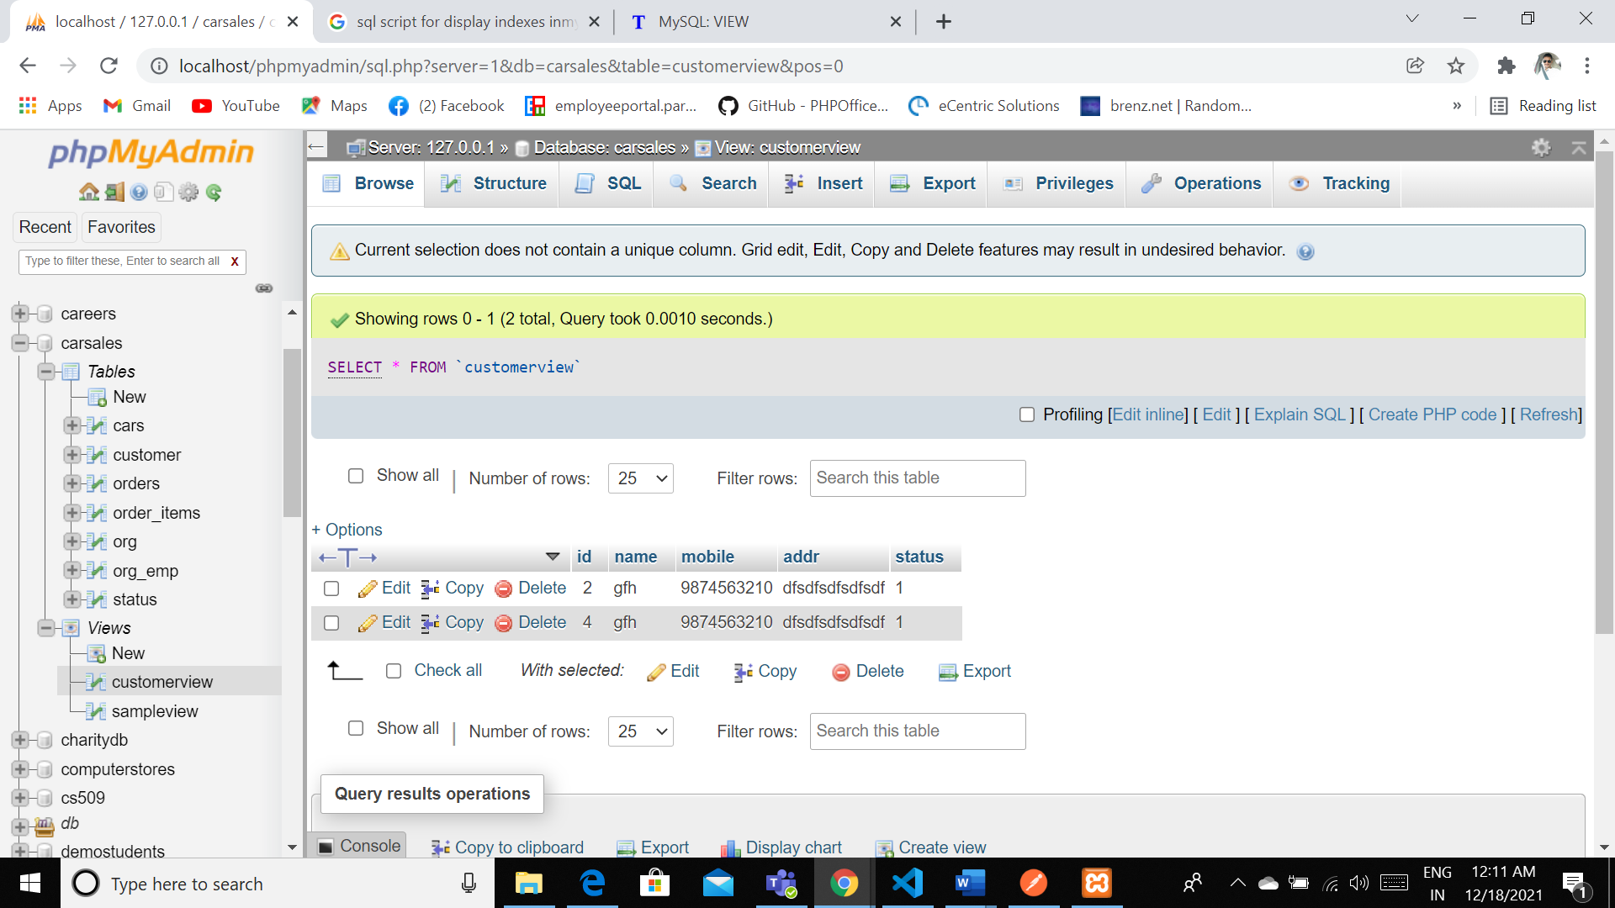

**Views**

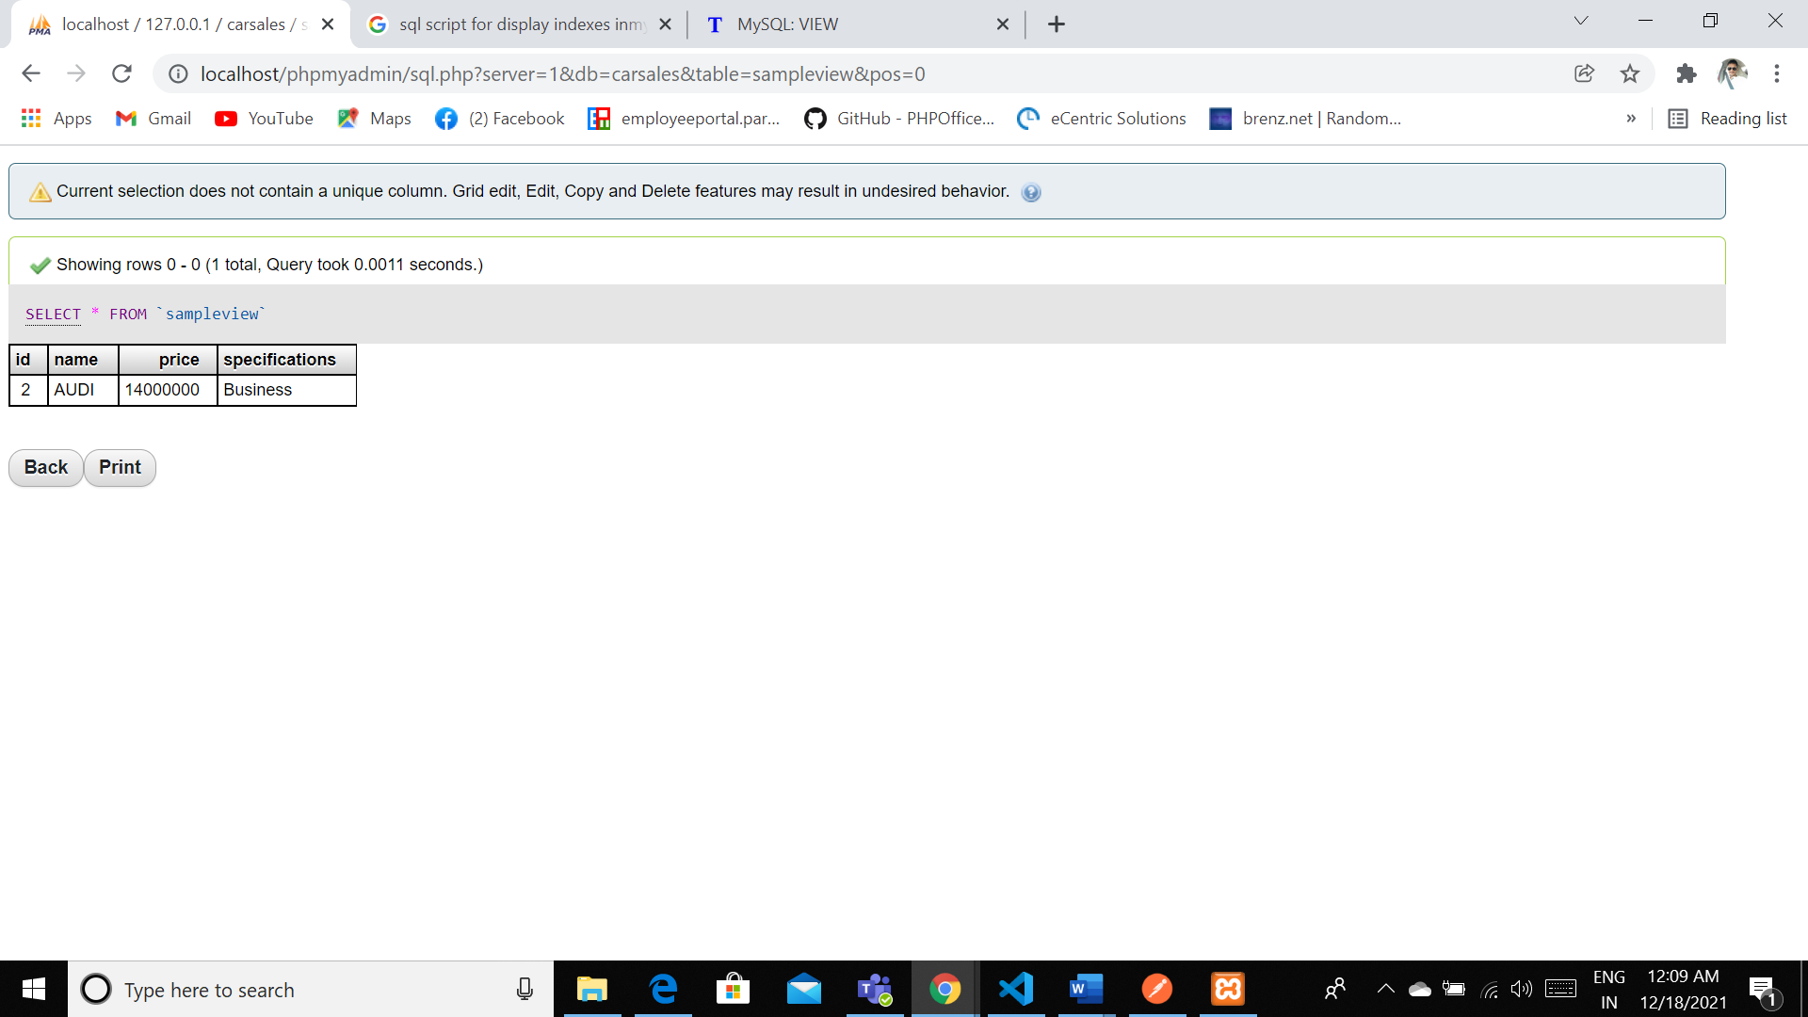

explaining why each view is a valuable addition to your database

By using these view we can easily define what exactly we can view and we can directly define what we can vie and that can be easily accessible by using the views.

explaining who might benefit most from having access to each view.

Stake holders can easily under stable by defining the required documentation using this views. That can be easily accessible.

Triggers:

CREATE TRIGGER price_sum BEFORE INSERT ON cars

FOR EACH ROW SET @sum = @sum + NEW.price

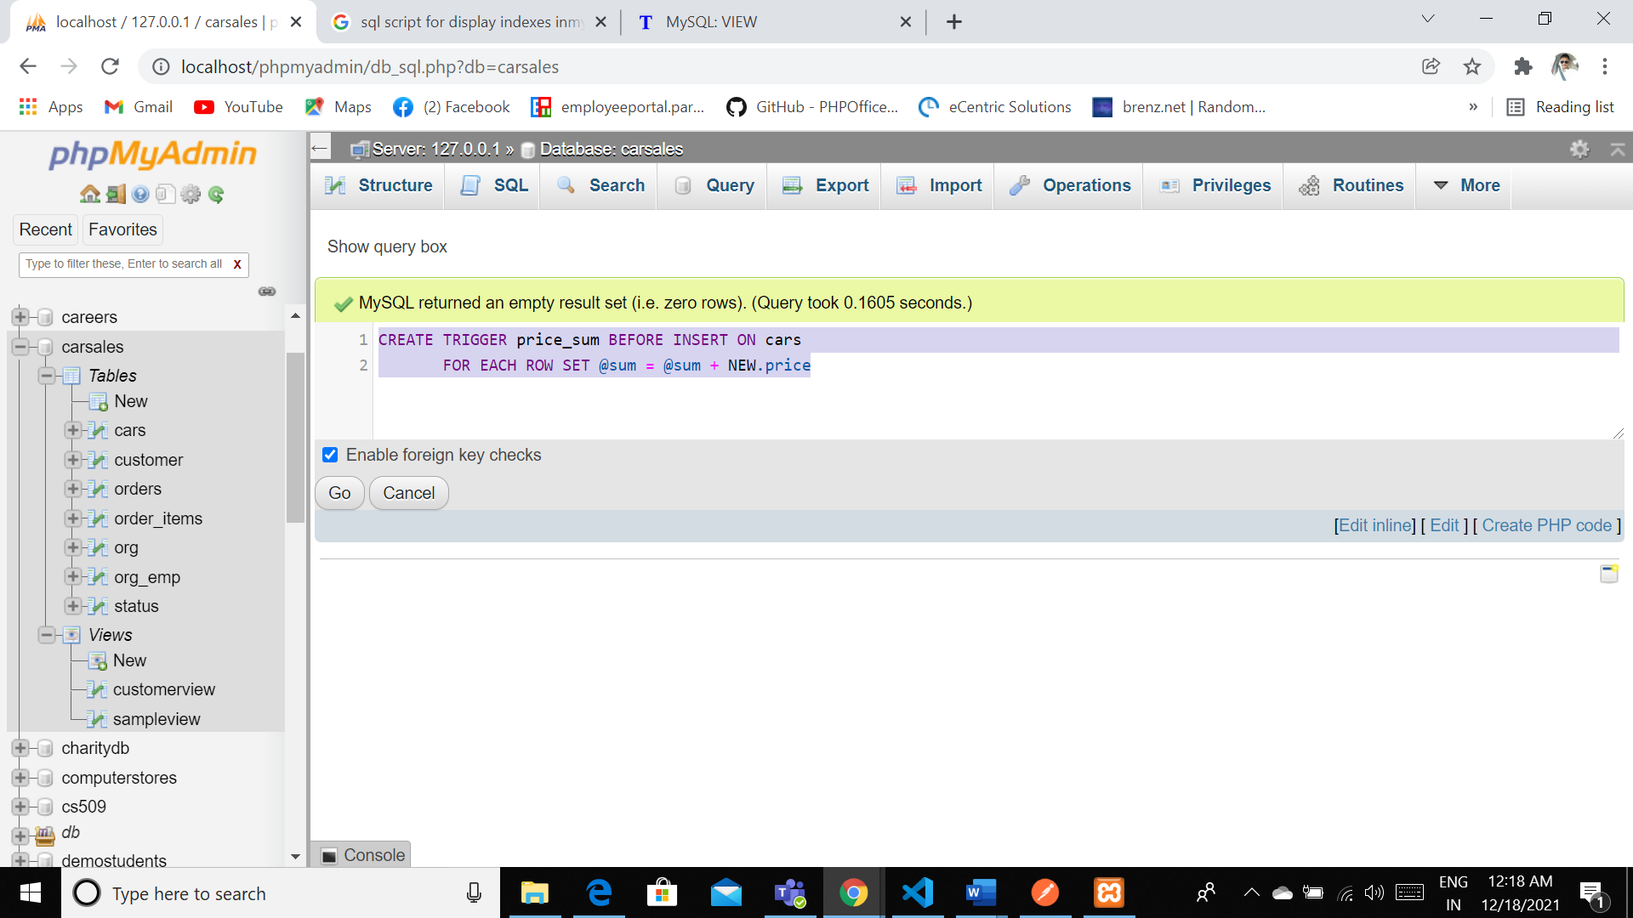

Generally Trigger will auto mated code blocks where we can define these triggers by using before or after the insertion /update or drop the data based on the condition

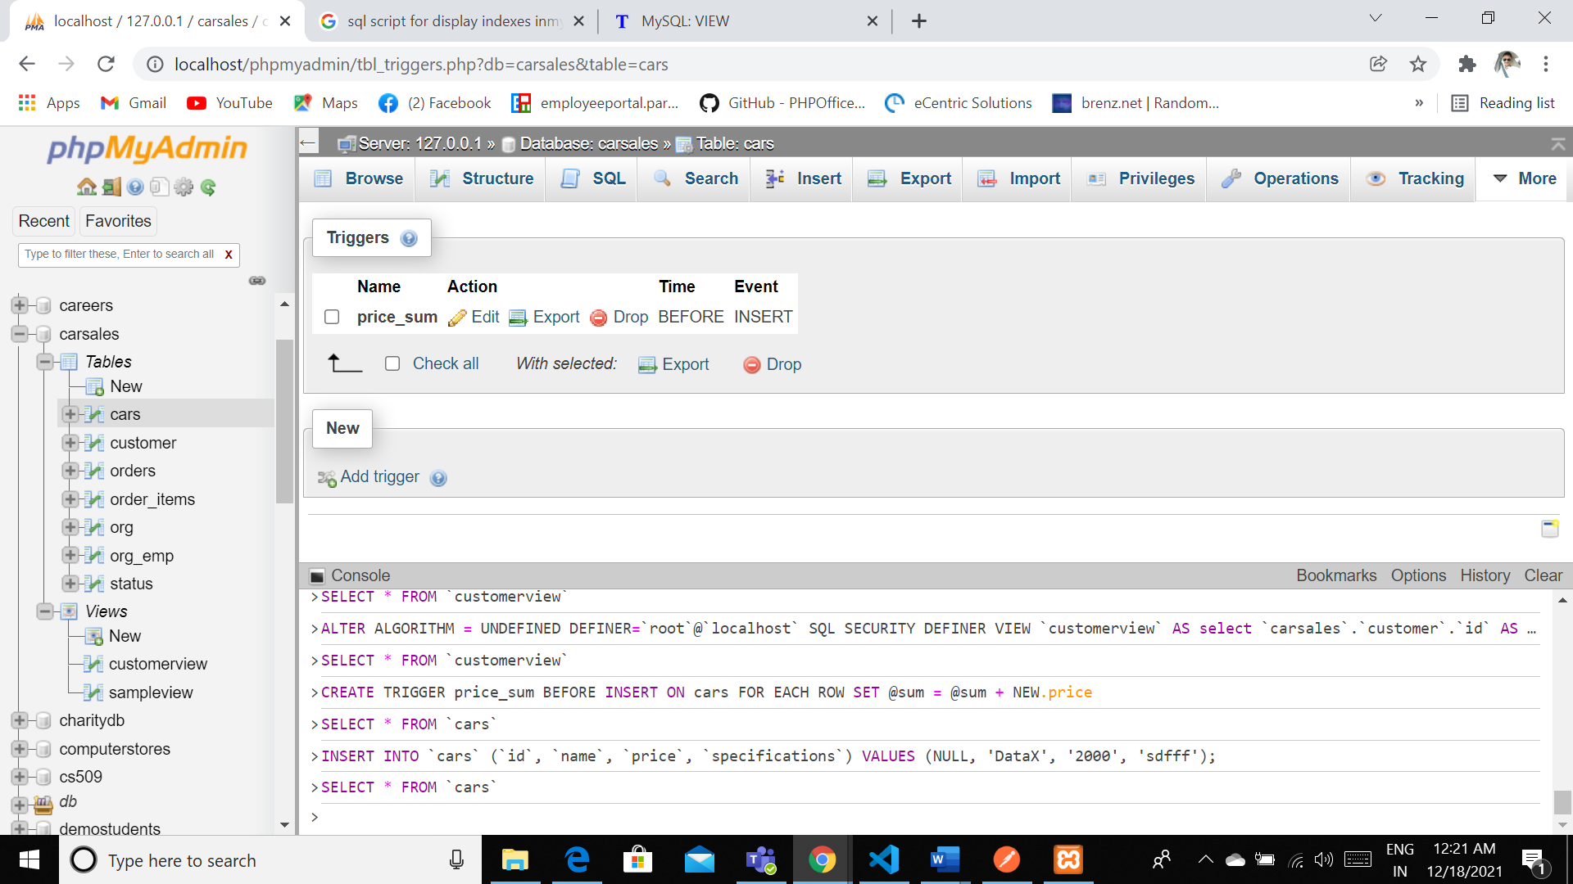

**Transactions**

Transaction are bit important as they were able to track the complete successful transmission of the data where they can be able to transfer the complete data using the ACID behavior

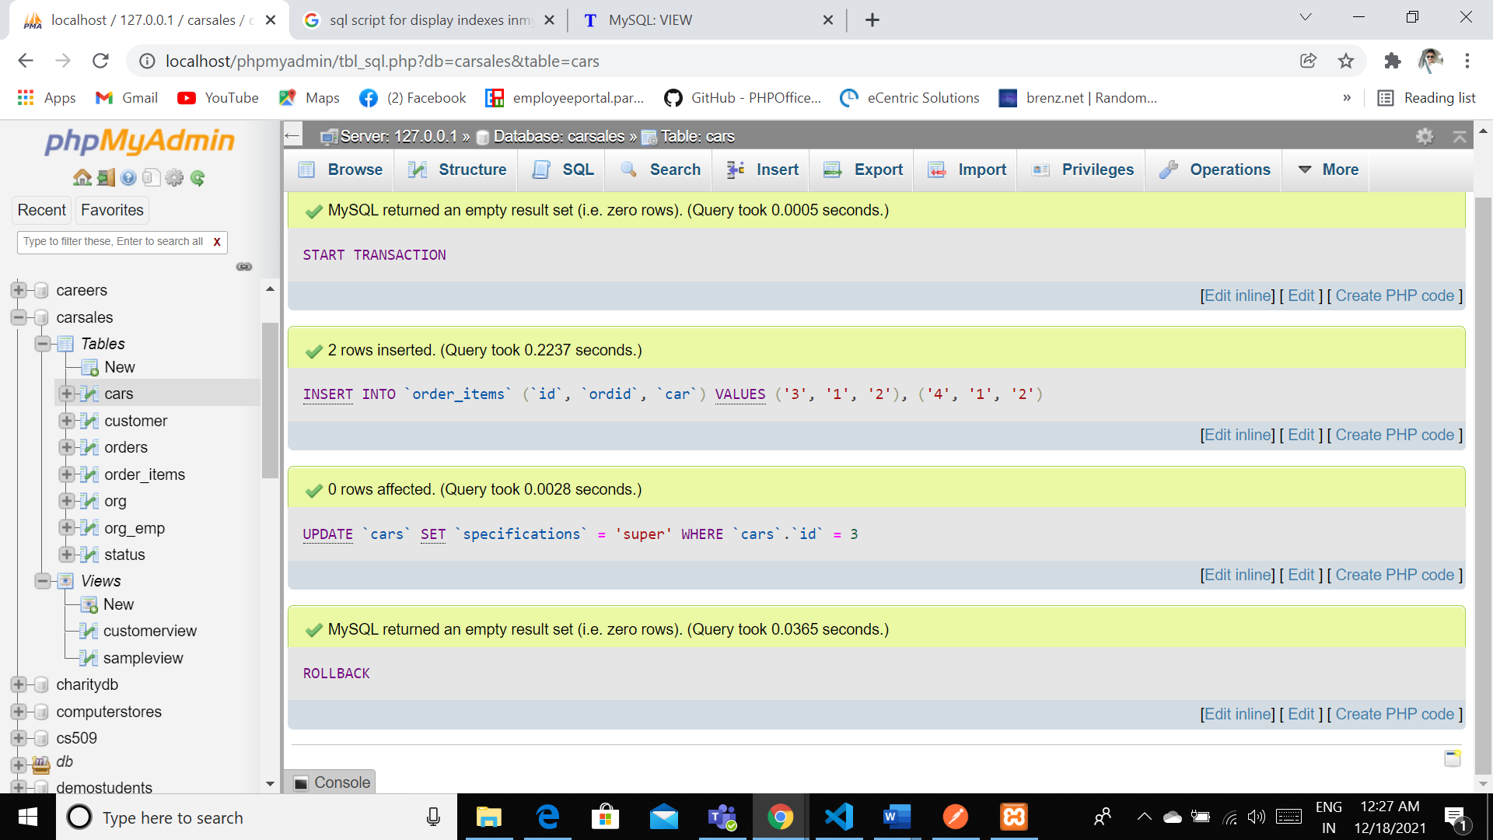

START TRANSACTION

[INSERT](http://localhost/phpmyadmin/url.php?url=https://dev.mysql.com/doc/refman/5.5/en/insert.html) INTO `order_items` (`id`, `ordid`, `car`) [VALUES](http://localhost/phpmyadmin/url.php?url=https://dev.mysql.com/doc/refman/5.5/en/miscellaneous-functions.html#function_values) ('3', '1', '2'), ('4', '1', '2')

[UPDATE](http://localhost/phpmyadmin/url.php?url=https://dev.mysql.com/doc/refman/5.5/en/update.html) `cars` [SET](http://localhost/phpmyadmin/url.php?url=https://dev.mysql.com/doc/refman/5.5/en/set.html) `specifications` = 'super' WHERE `cars`.`id` = 3

ROLLBACK

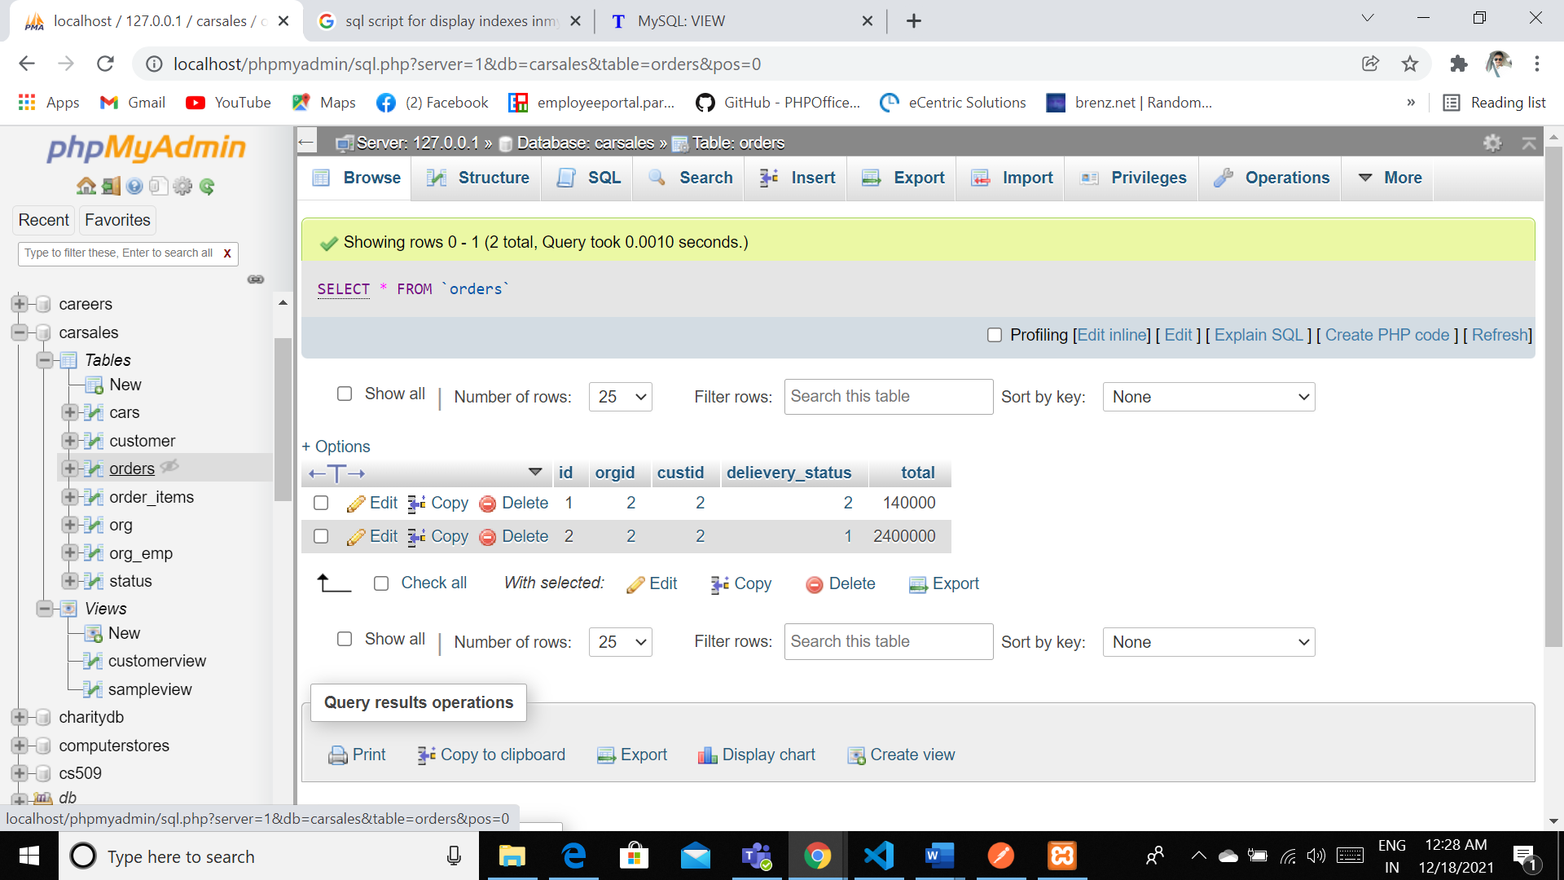

I have inserted 2 rows in this area and finally iahave called rolled out so the complete transation is being rolled back this is the major advantage we have tith the Transations.

**Security**

(SELECT DISTINCT `User`, `Host` FROM `mysql`.`user` ) UNION (SELECT DISTINCT `User`, `Host` FROM `mysql`.`db` ) UNION (SELECT DISTINCT `User`, `Host` FROM `mysql`.`tables_priv` ) UNION (SELECT DISTINCT `User`, `Host` FROM `mysql`.`columns_priv` ) UNION (SELECT DISTINCT `User`, `Host` FROM `mysql`.`procs_priv` ) ORDER BY `User` ASC, `Host` ASC

The follow screen shot will define the list of the user privileges that we will hold the database users.

Generally we have two types of users by default root user and other user root user will have all tha privileges and other iser we need to grant the privileges the preivilages can al show we can grant or some times we they need to get it.

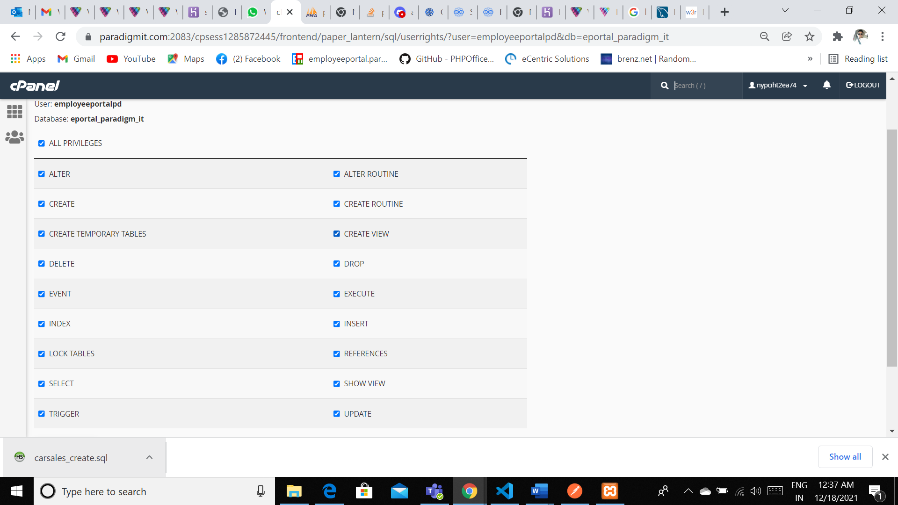

GRANT ALL PRIVILEGES ON carsales.* TO 'root'@'localhost';

Locking:

[LOCK](http://localhost/phpmyadmin/url.php?url=https://dev.mysql.com/doc/refman/5.5/en/lock-tables.html) [TABLES](http://localhost/phpmyadmin/url.php?url=https://dev.mysql.com/doc/refman/5.5/en/lock-tables.html) customer WRITE

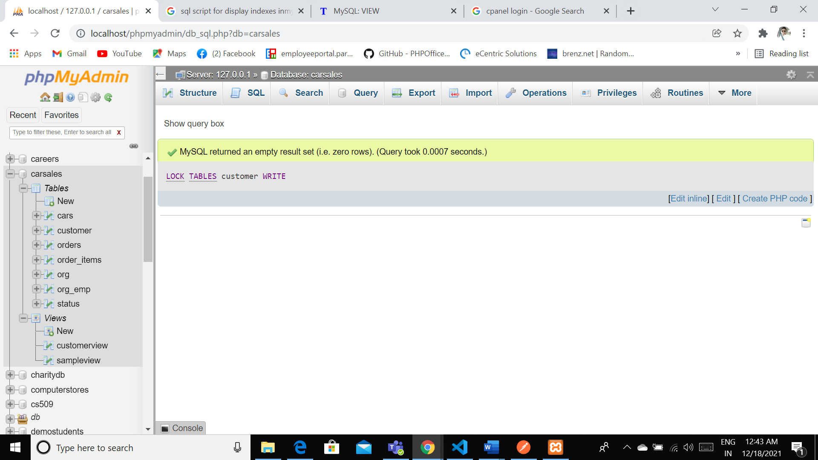

We can lock the table in order to secure the unwanted insertion or accessing the some of the major tables so that they need to organize the consistency in projecting the data to the database.

**Backup**

Pull back up we will run a script that automatically triggers end up backed up automatically within the location where the complete code will be in a secure mode where uh we will prevent all the all did read and write access for all the users so that no one can able to access the backup files. We will run this I’m back up a Cron job uhm for every fortnight so that every day we could be able to backup the complete database and we can get the complete data with consistent frequency. And all the all the backup files will be yes 256 encrypted so that no one could able to access decoding the scripts.

set path=c:\wamp\bin\mysql\mysql5.1.36\bin

C:\xampp\mysql\bin\mysqldump.exe -u{root} -p{} carsales > {/backuppath}.sql

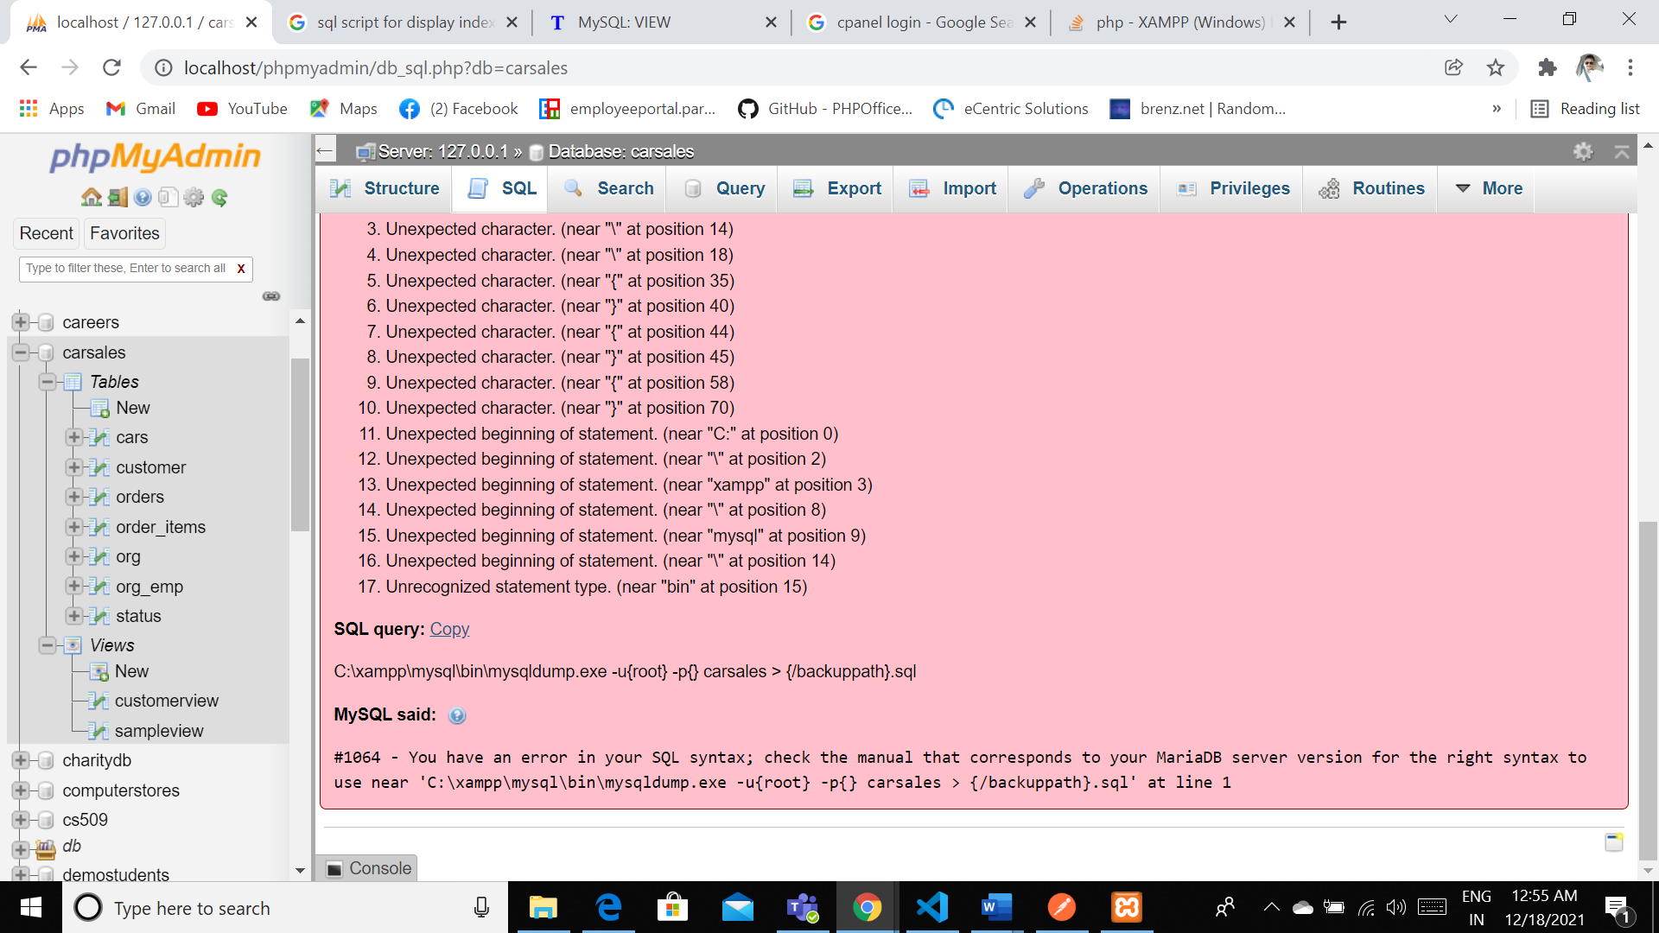

Python:

Write a Python program that generates a report that contains a subset of the data from your database. Include the code for your Python program in your Word document **report**, and also post the program to your **GitHub** repository.

from __future__ import print_function

hostname = 'localhost'

username = 'root'

password = ''

database = 'carsales'

# Simple routine to run a query on a database and print the results:

def doQuery( conn ) :

cur = conn.cursor()

cur.execute( "SELECT * FROM cars" )

for name in cur.fetchall() :

print( name )

print( "Connected successfully:" )

import mysql.connector

myConnection = mysql.connector.connect( host=hostname, user=username, passwd=password, db=database )

doQuery( myConnection )

myConnection.close()

